Mobile App Development Report

April 23
Name: seif elbosaty

Table of Contents
- Project Description
  - Introduction
  - Project Background
  - Motivation
  - Project Goals
- Another Application
- UI/UX Considerations
- Game Testing
- Proposed Application Modeling
  - Use Case Diagram
  - Use Case Scenarios
  - Activity Diagram
- Product Database
- Resources

1. Project Description

Introduction
"The Mission" is a 2D car-based game developed in Unity using C#. The game has a unique mechanic where players must switch cars based on the terrain of three distinct maps. If the player fails to switch to the correct car in time, they lose the game. Additionally, players can collect coins to upgrade their cars. The game features a login system to allow users to save their progress, high scores, and car upgrades.
The main goals of this project are:
- To develop an engaging and challenging time based car switching game.
- To integrate a login system for user authentication and progress tracking.
- To implement a scoring system with upgradeable features for an immersive experience.
- To ensure a seamless UI/UX design with smooth gameplay mechanics.

Project Background
This project requires a combination of software and hardware resources. The game is developed using:
Software:
- Unity Engine (for 2D game development)
- C# Programming Language (for scripting)
- SQLite/Firebase (for backend storage and authentication)
- Visual Studio Code (for coding and debugging)
Hardware:
- MacBook with an M1 chip (development & testing)
- Standard keyboard & mouse for control setup
Development Steps:
- Setting up the Unity environment and project structure.
- Designing game assets and implementing the core mechanics.
- Implementing the car-switching logic.
- Developing UI elements (login screen, dashboard, etc.).
- Integrating user authentication and data storage.
- Testing and debugging.
- Optimizing performance and releasing the final version.

Motivation
The game is designed to test players’ quick decisionmaking and reaction time. Many existing games focus on endless driving or obstacle avoidance, but "The Mission" brings a new twist by requiring players to adapt quickly to different terrains. The main challenges during development include:
- Ensuring smooth car switching: Implementing the logic so players can swap cars in real time without glitches.
- Data storage and retrieval: Saving user progress securely while ensuring efficient database performance.
- UI/UX optimization: Designing an intuitive interface that enhances player experience.
To overcome these challenges, online resources such as Unity documentation, game development tutorials, and forums like Stack Overflow will be utilized.

Project Goals
The game should allow users to:
- Login and sign up using a username and password.
- Save and load game progress, including coins collected and cars upgraded.
- View and manage high scores.
- Upgrade cars based on coins collected.
- Seamlessly switch between cars based on the current terrain or map.

2. Another Application
A similar game concept can be found in “Hill Climb Racing”, which involves driving across different terrains. However, "The Mission" is unique because:
- Players must actively switch cars instead of just upgrading them.
- The game has a timebased failure mechanic where failing to switch cars at the right time results in a loss.
- The game includes a user authentication system, allowing players to track their progress over multiple sessions.
3.UI/UX Considerations:
- The UI is simplified using the following:
- Basic main menu with intuitive navigation
- Explicit feedback mechanisms for player actions
- Responsive controls, e.g., touch and keyboard input
- Security Considerations
To make it more secure:
- Passwords are hashed using bcrypt before storage
- User sessions are processed securely to prevent unauthorized access
4. Game Testing
Unit Testing:
- Authentication scripts, score calculation scripts, and UI update scripts are unit tested.
Playtesting:
- Players play a beta version of the game to gather feedback regarding controls, responsiveness, and difficulty levels.
Automated Testing:
- Unity Test Framework is used for automated gameplayand UI testing to find problems before release.
Conclusion:
- The game makes use of Unity for effective 2D rendering, Firebase for secure authentication and data storage, and best practices for performance and security. Planned future developments include adding more car choices, adding leaderboards, and implementing multiplayer.

5. Proposed Application Modeling

Use Case Diagram
The use case diagram will illustrate the interactions between the player and the game’s features.
Main actors and use cases:
- Player can:
  - Log in / Sign up
  - Start the game
  - Switch cars
  - Collect coins
  - Upgrade cars
  - View high scores
  - Save progress

Use Case Scenarios
- Login System:
  - The player enters their username and password.
  - If credentials match, the system retrieves the saved game progress.
  - If incorrect, an error message appears.
- Car Switching Mechanic:
  - The game detects the upcoming terrain.
  - The player is prompted to switch cars.
  - If the correct car is chosen, the game continues.
  - If no action is taken, the player loses.

Use case diagram:
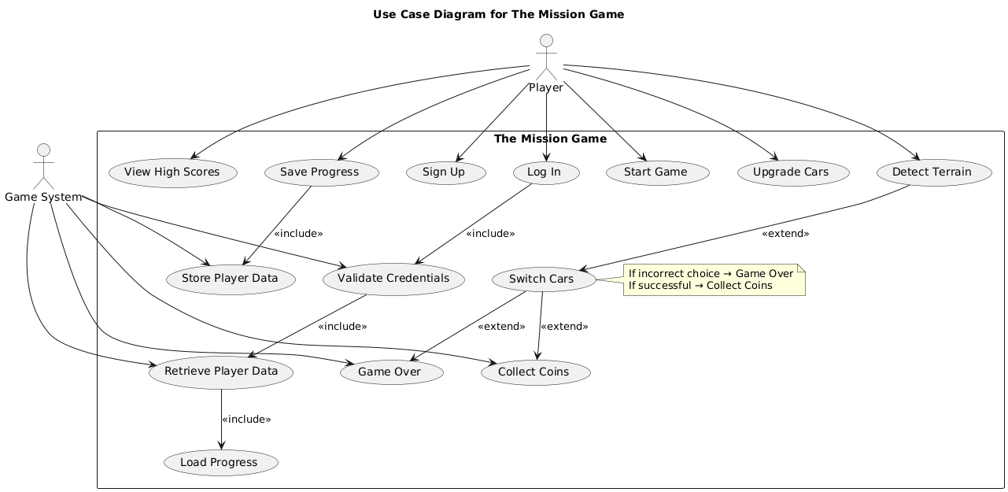

Activity Diagram
The activity diagram will represent the game flow:
- Player logs in.
- Player selects the game mode.
- Game starts.
- Player collects coins and navigates through maps.
- If the correct car is switched in time → Continue.
- If not switched in time → Game over.
- Player can restart or exit.
Activity diagram:
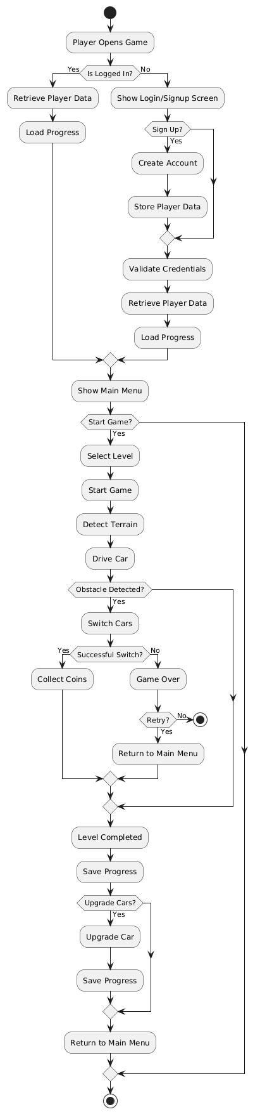

6. Product Database

Backend Description
The backend will be responsible for managing:
- User authentication (storing usernames & passwords securely).
- Game progress storage (saving high scores, collected coins, upgrades).

Why Backend is Needed
A backend is required to ensure users can continue their progress across different devices and sessions.

Stored Data:
- User Credentials (Username, Encrypted Password)
- Progress Data (Coins collected, Cars upgraded, High scores)
- Game Settings (User preferences, selected car skins, etc.)

7. References:
Some references I used and will use:
- Game Development & Unity
  - Gregory, J. (2018). Game Engine Architecture. CRC Press.
  - Unity Technologies. (n.d.). Unity Manual & Scripting API. https://docs.unity3d.com/
  - Nystrom, R. (2014). Game Programming Patterns. Genever Benning.
- Authentication & Data Storage
  - Firebase Documentation. (n.d.). Firebase Authentication and Realtime Database. https://firebase.google.com/docs/
  - Schneier, B. (1996). Applied Cryptography: Protocols, Algorithms, and Source Code in C. John Wiley & Sons.
- UI/UX in Game Design
  - Isbister, K. (2016). How Games Move Us: Emotion by Design. MIT Press.
  - Norman, D. (2013). The Design of Everyday Things. Basic Books.
- Real-Time Decision Making in Games
  - Yannakakis, G. N., & Togelius, J. (2018). Artificial Intelligence and Games. Springer.
  - Salen, K., & Zimmerman, E. (2004). Rules of Play: Game Design Fundamentals. MIT Press.

